Solidity
(important notes and highlights)
Read this file and you will recall everything you need

Honstly just try to understand how everything works underneath it, chatgpt will code the syntax for you! We need to learn the way things work.
When we deploy a contract, an instance is made:
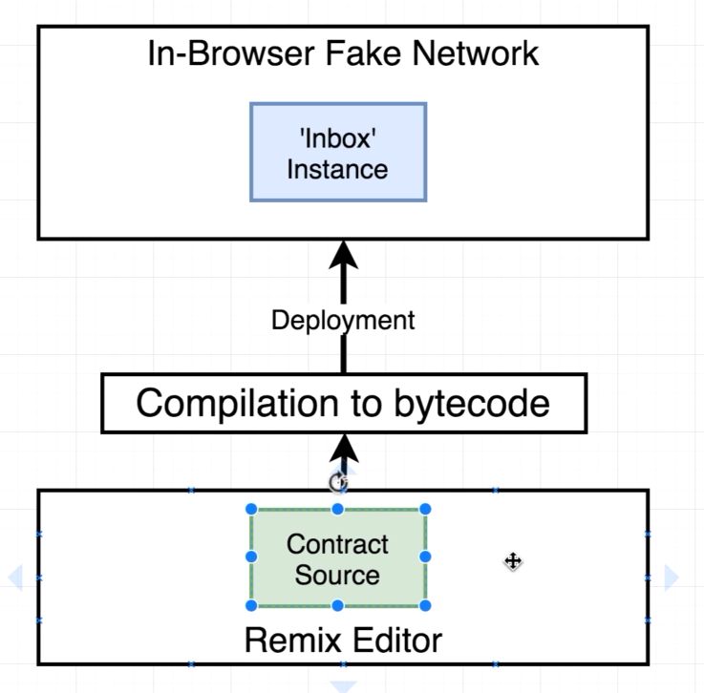
And remember deployed contracts are there in the network forever.
First example contract:
pragma solidity >=0.8.2 <0.9.0; //this defines the compiler version

contract test1{
string public message;

constructor(string memory initMessage){
message = initMessage;
}

function setter(string memory newMessage) public {
message = newMessage;
}

function getter() public view returns (string memory) {
return message;
}
}

We deployed and used the setter and getter; deployment is 1 Tx and using the setter is 1 Tx. Getter() is public view.
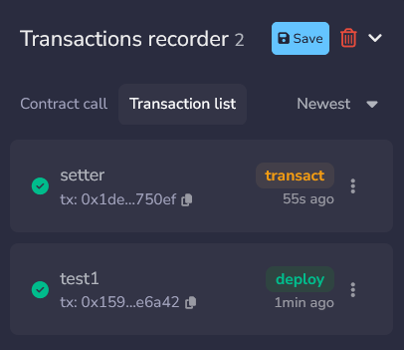
Now, if you make a change to your code the previously deployed contracts will stay. I told you! They will stay forever and you can interact with them with their old functioning and logic.
Txs that deploy a contract are like this:
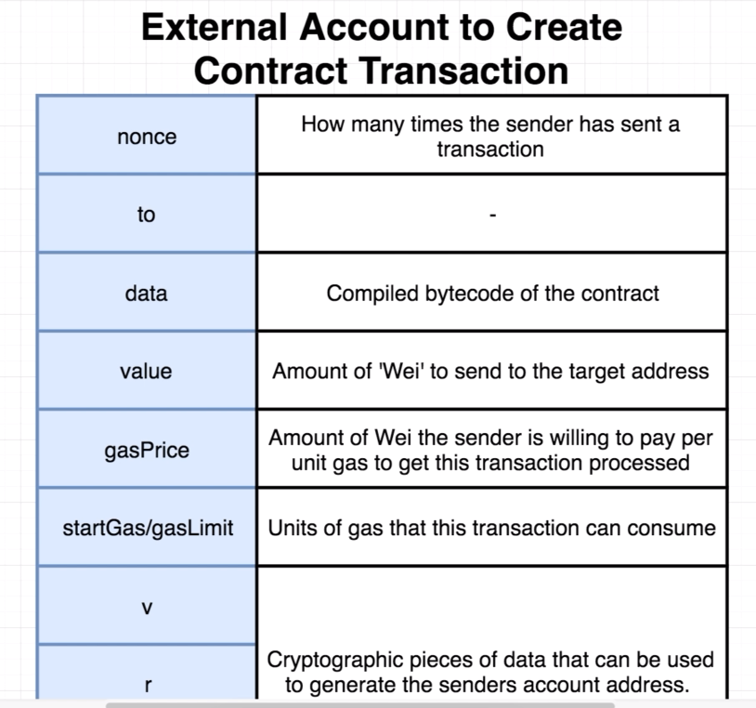
As you can see the Bytecode is the open-source contract code! There is no signature or anything saying who wrote this code! You just deploy it.
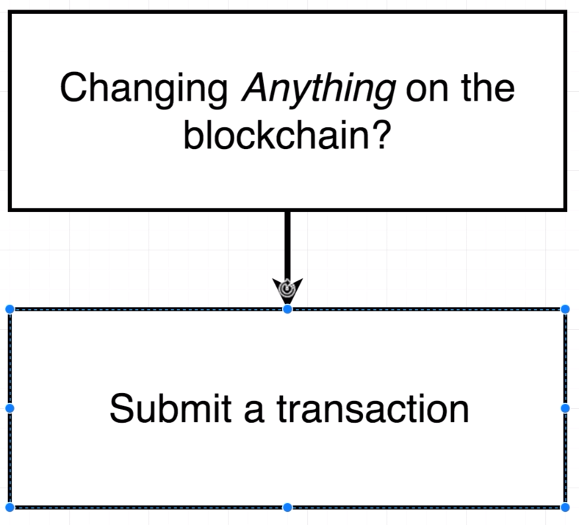
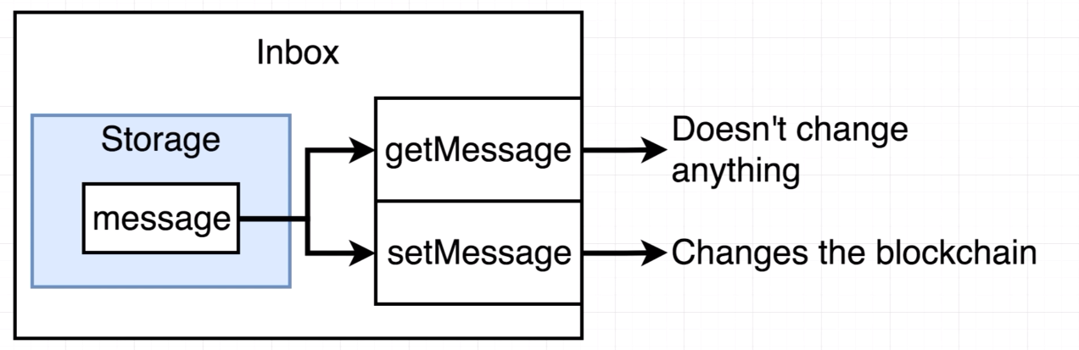
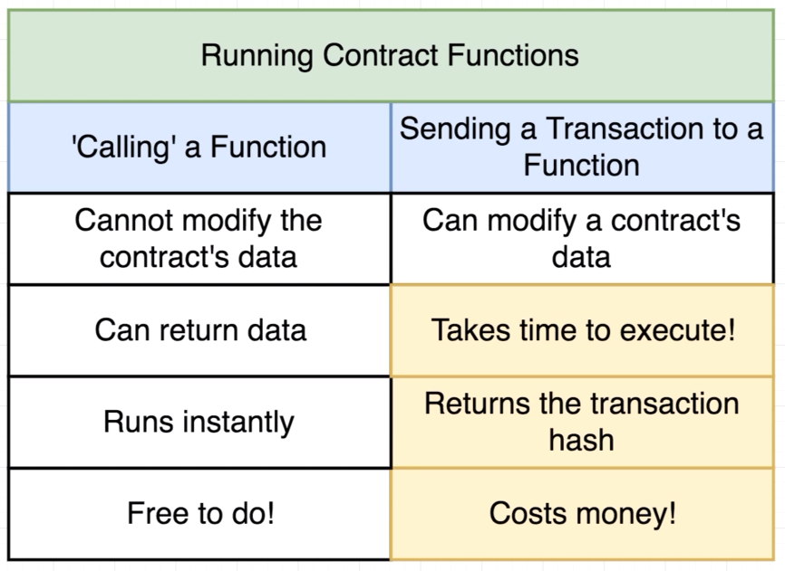
Important point: Tx take time, unlike the toy local networks that works instantly. Watch this Gottcha!
Look at these functions:
function doMath(uint a, uint b) private pure returns (uint) {
uint c = a * b;
return c;
}
function UseDoMath(uint d) public pure returns(uint){
uint a = 8;
uint b = 16;
uint c = doMath(a,b);
uint e = d * c;
return e;
}
They don’t deal with the storage so they are pure and we “Call” them we don’t “Transact” them.
It's always advisable to be explicit when specifying the length of the data type. Uint256 is an example.
Bytes are a collection of characters written in hexadecimal representation.
bytes1 minBytes = "I am a fixed size byte array of 1 byte";
bytes32 maxBytes = "I am a fixed size byte array of 32 bytes";
bytes dynamicBytes = "I am a dynamic array, so you can manipulate my size";

Every variable in Solidity comes with a default value. Uninitialized uint256 for example, defaults to 0 (zero) and an uninitialized boolean defaults to false.
Different visibilities: You see everything on BlockChain is public you can’t hide this. You are just restricting its access.
- 🌎 public: accessible from both inside the contract and from external contracts. It actually creates a getter function!
- 🏠 private: accessible only within the current contract. It does not hide a value but only restricts its access.
- 🌲 external: used only for functions. (can be used only by this.function())
- 🏠🏠 internal: accessible by the current contract and any contracts derived from it.
If a visibility specifier is not given, it defaults to internal.
View -> when only reading from the blockchain storage i.e. reading the state.
Pure -> not doing anything with the storage at all.
While calling view or pure functions doesn’t typically require gas, they do require it when called by another function that modifies the state or storage through a transaction (e.g. calling the function retrieve inside the function storage). This cost is called execution cost and it will add up to the transaction cost.
Arrays are zero-indexed: the first element is at position zero
Structs:
struct Person {
uint256 my_favorite_number;
string name;
}
Person public my_friend = Person(7, 'Pat');
Arrays:
Person[] public list_of_people; // this is a dynamic array
Person[3] public another_list_of_three_people; // this is a static array

Calldata and Memory
In Solidity, calldata and memory are temporary storage locations for variables during function execution. calldata is read-only, used for function inputs that can't be modified. In contrast, memory allows for read-write access, letting variables be changed within the function. To modify calldata variables, they must first be loaded into memory.
And finally I deployed my first contract in a real testnet blockchain: Yoohoo!
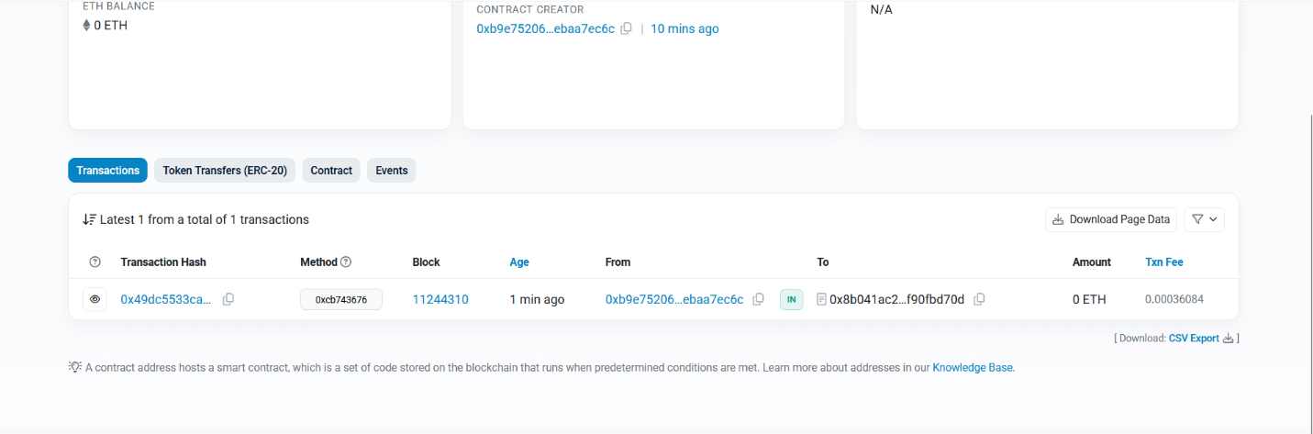

And this is the code for the transaction, my first ever contarct:
// SPDX-License-Identifier: MIT
pragma solidity >=0.8.2 <0.9.0;

contract test1{
string public man = "hello"; //can't set memory or storage always by default storage

struct cat{
string name;
string color;
uint256 age;
}
cat shamim = cat("Shamim", "Black", 2);
cat fandogh = cat({name : "fandogh", color : "White", age : 5}); //2 ways to make structs

cat[] public CatList; //can't set the array here likr this: ---- cat[] public CatList = [shamim, fandogh] ----if you want to initialize set it in the constructor.

mapping(string => int256) catLoyalty;

constructor(){
CatList.push(shamim);
CatList.push(fandogh);
catLoyalty[shamim.name] = -10;
catLoyalty[fandogh.name] = -8;
}

function doMath(uint a, uint b) private pure returns (uint) {
uint c = a * b;
return c;
}

function AddCat(cat memory _cat) public{
CatList.push(_cat);
catLoyalty[_cat.name] = 0;
}

function getCat(uint _id) public view returns(cat memory){
return CatList[_id];
}

function getLoyalty(string memory _name) public view returns (int256){
return catLoyalty[_name];
}
}

Deploying a Contract From another Contract
Importing from another .sol file:
import { SimpleStorage} from "./SimpleStorage.sol";
When deploying a contract from another contract. When calling the public variable of the contract we get the address:
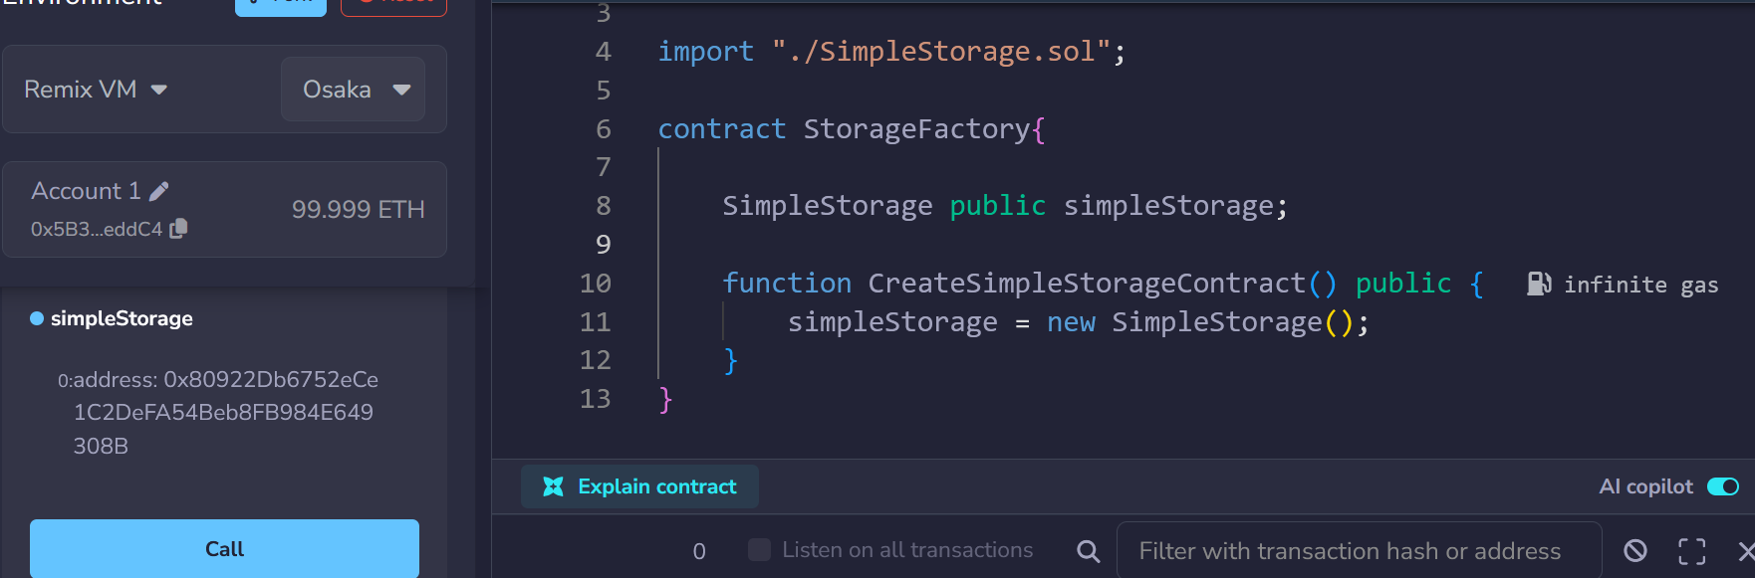
Every time you have to interact with another contract, you need:
- the contract address (the contract variable is an address itself, in fact we can do a type change like: address(SimpleStorage))
- the contract ABI (Application Binary Interface): a standardized way for interacting with the binary version of a smart contract deployed on the blockchain. It specifies the functions, their parameters, and the structure of the data that can be used to interact with the contract. It's generated by the compiler. These are the blue and orange buttons in remix.
function sfGet(uint256 _simpleStorageIndex) public view returns (uint256) {
// return SimpleStorage(address(simpleStorageArray[_simpleStorageIndex])).retrieve();
return listOfSimpleStorageContracts[_simpleStorageIndex].retrieve();
}
It’s simple OOP don’t take it too hard.

Inheritance
import {SimpleStorage} from "./SimpleStorage.sol";
​
contract AddFiveStorage is SimpleStorage {}

overriding:
TypeError: Overriding function is missing "override" specifier.
To override a method from the parent contract, we must replicate the exact function signature, including its name, parameters and adding the visibility and the override keyword to it:
function store(uint256 _newFavNumber) public override {}
Yet, another error will pop up:
TypeError: Trying to override a non-virtual function.
To address this, we need to mark the store function in SimpleStorage.sol as virtual, enabling it to be overridden by child contracts:
function store(uint256 favNumber) public virtual {
// function body
}

Payable
If you want to send money and increase the balance of a contract, the function should be payable.
For example, if you wanna send some money while deploying the contract, the constructor must be payable:
contract CrowdFund{
address public owner;

constructor() payable {
owner = msg.sender;
}

function fund() public payable{
if (msg.sender == owner){ //if the owner wants to fund there is no limit
return;
}
require(msg.value >= 1e18);//1e18 = 10 ** 18 wei = 1 ETH others atleast 1 Eth
}
}

Reverts
function fund() public payable{
uint256 c = a * b;
c = c ** 2
//bluh bluh bluh
require(msg.value >= 1e18)
//tons of computation
}
If the require fails, all the things happened in the scope of function revert. However since EVM has done some computation for us before the require the gas still is spent! The operations after the require won’t happen and won’t spend gas.
A point about reverts in EVM:
Key point: The EVM does not first commit the changes and then undo them. It executes against a temporary state snapshot. If execution succeeds, the snapshot is committed. If it reverts, the snapshot is simply discarded—all within the processing of that single transaction in the same block.

Oracles
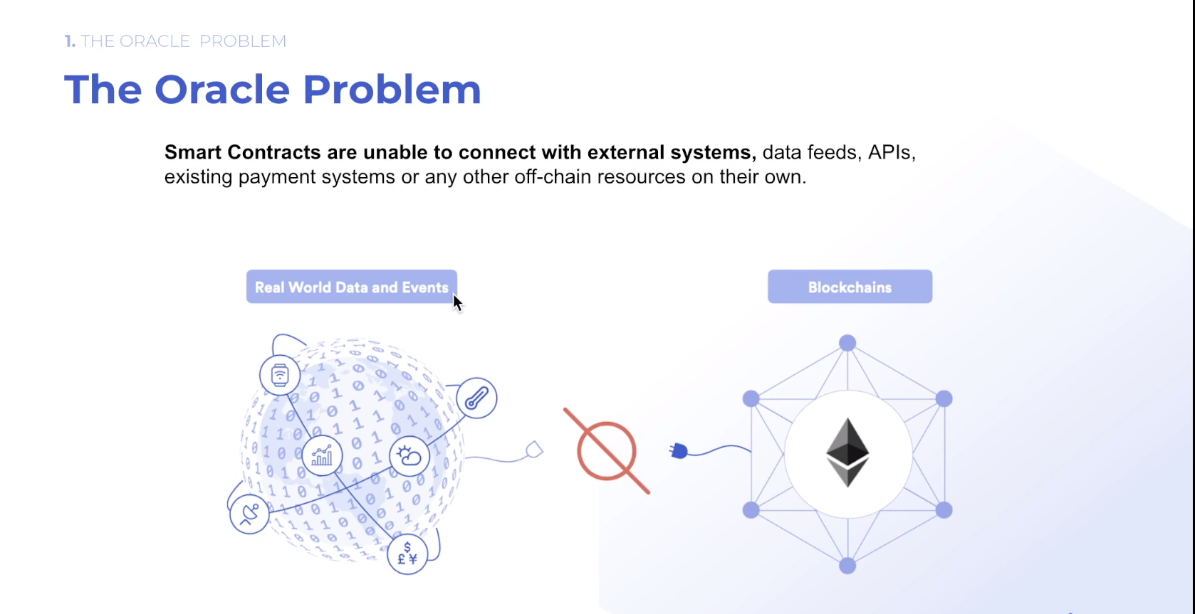
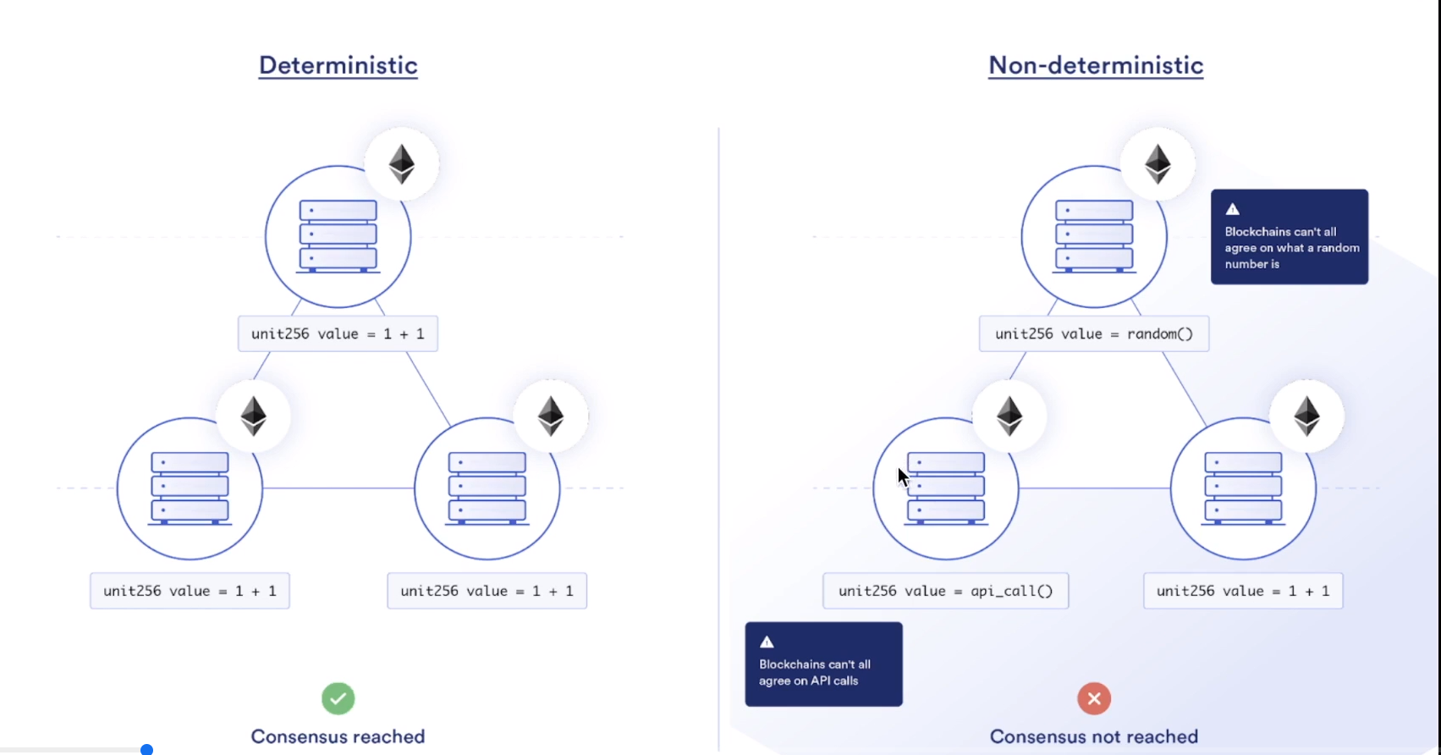
Block chain oracle provides a way to connect the blockchain to the real world.
However:
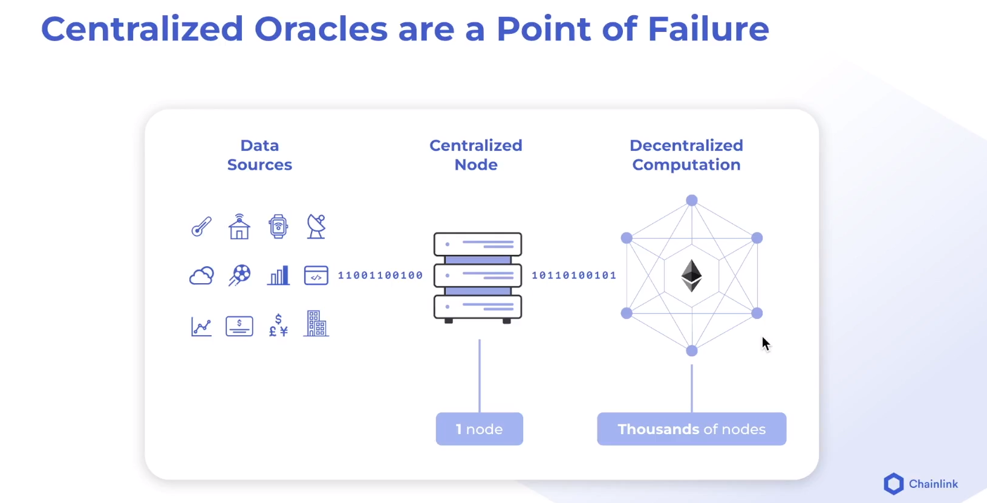
This is against the whole point of the Web3!
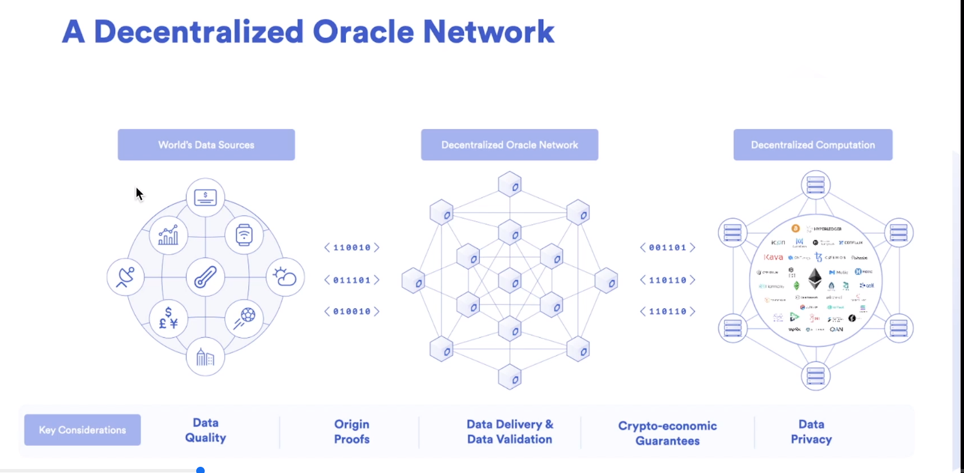
So how does it work?
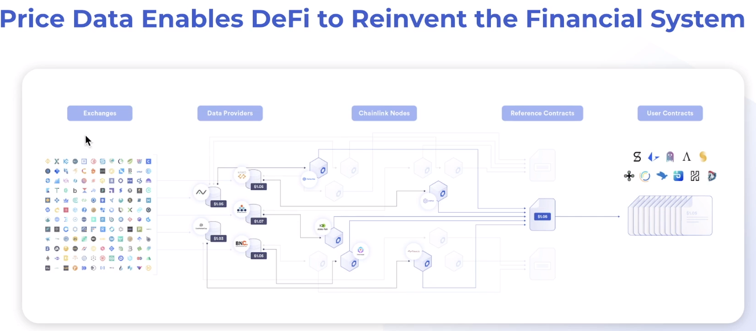
It has deployed a reference contract and updates it in the blockchain with a transaction say for example once every 1 hour, and all the other contracts call and fetch data from the deployed contracts! EZ PZ

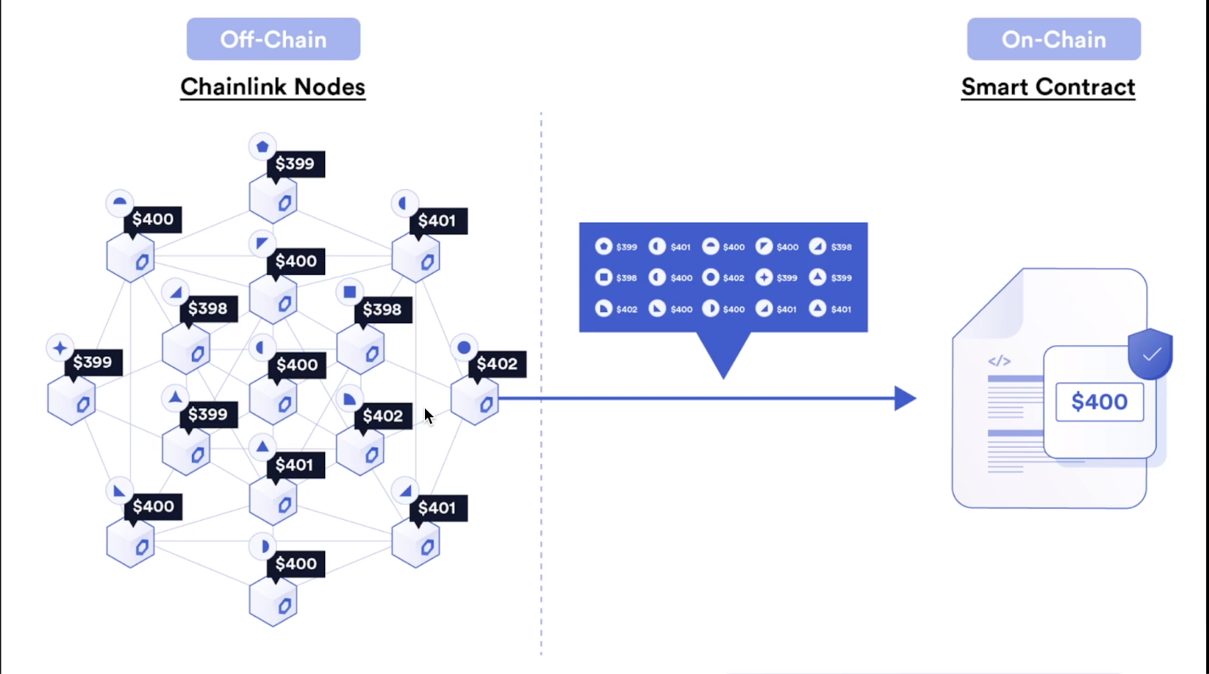

Use docs.chain.link to see the addresses of each deployed reference contract. (use chatgpt to fetch the link and do the job), I deployed one for sepolia using this code:
// SPDX-License-Identifier: MIT
pragma solidity ^0.8.7;

import {AggregatorV3Interface} from "@chainlink/contracts@1.5.0/src/v0.8/shared/interfaces/AggregatorV3Interface.sol";

contract DataConsumerV3 {
AggregatorV3Interface internal dataFeed;

constructor() {
dataFeed = AggregatorV3Interface(0x1b44F3514812d835EB1BDB0acB33d3fA3351Ee43);
}

function getChainlinkDataFeedLatestAnswer() public view returns (int256) {
// prettier-ignore
(
/* uint80 roundId */
,
int256 answer,
/*uint256 startedAt*/
,
/*uint256 updatedAt*/
,
/*uint80 answeredInRound*/
) = dataFeed.latestRoundData();
return answer;
}
}

Here are the addresses for each network you are deploying on and all the converters:
https://docs.chain.link/data-feeds/price-feeds/addresses?networkType=testnet
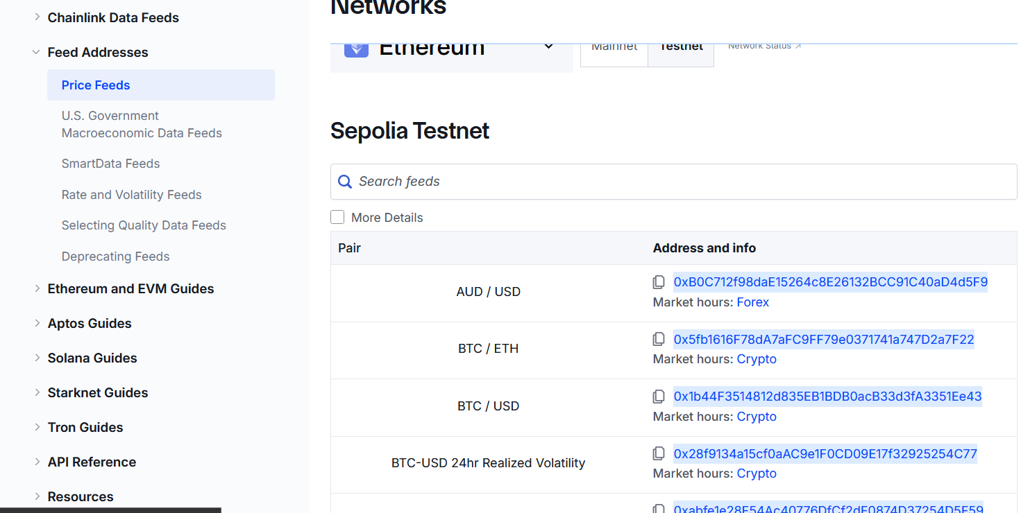

Interfaces (important thing here)
difference between solidity contract interfaces, and simply making an obj of another contract in my contract? Is it the same thing?
Basically, Yes!
- Interface (interface): A declaration of another contract's external functions. It contains only function signatures (no implementation, no state). You use it when you only need to call another deployed contract. (that other people have deployed)
interface IERC20 {
function transfer(address to, uint amount) external returns (bool);
}

IERC20 token = IERC20(tokenAddress);
token.transfer(user, 100);
- Contract object (OtherContract other = OtherContract(addr)): You're using the full contract type. It also lets you call the contract at addr, but you have access to everything defined in that contract's ABI (functions, public getters, etc.). It is usually used when we want to deploy a contract inside another contract and play around.
OtherContract other = OtherContract(addr);
other.someFunction();

//this is usually used for new deployment:
OtherContract other = new OtherContract();
Other.someFunction();

Are they the same?
At runtime, yes—both are just treating an address as a contract and making external calls.
The difference is in the type information:
- Interface: Minimal API, looser coupling, common for interacting with external contracts.
- Contract type: Full contract definition, useful when you own or know the complete contract.
Think of an interface as a header/API contract, while a contract type is the full class definition.
Interface is lighter and is like an API. It’s used to play with already deployed contracts. We use a full contract type if we have written it ourself and we want to play around with it (deploy it etc’).
Back to getting real prices.

Decimals
- msg.value is a uint256 value with 18 decimal places. -> (1 , 18) 1 wei is 10e-18
- answer is an int256 value with 8 decimal places (USD-based pairs use 8 decimal places, while ETH-based pairs use 18 decimal places). (173000000000, 8) is 1,730 $ USD so we make it (173000000000 * 1e10, 18) now all numbers we see we know we have 18 decimals
This means the price returned from our latestRoundData function isn't directly compatible with msg.value. To match the decimal places, we multiply price by 1e10:
return price * 1e10;
all numbers are whole so we make a global # of decimals for better convenience.
Always multiply before dividing to maintain precision and avoid truncation errors. For instance, in floating-point arithmetic, (5/3) * 2 equals approximately 3.33. In Solidity, (5/3) equals 1, which when multiplied by 2 yields 2.
The code for conversion:
function ETHtoUSD() public view returns (uint256){
AggregatorV3Interface dataFeed = AggregatorV3Interface(0x694AA1769357215DE4FAC081bf1f309aDC325306);

(
/* uint80 roundId */
,
int256 answer,
/*uint256 startedAt*/
,
/*uint256 updatedAt*/
,
/*uint80 answeredInRound*/
) = dataFeed.latestRoundData();
return uint256(answer * 1e10);
}

function getprice(uint256 EthValue) public view returns(uint256){
uint256 price = ETHtoUSD();
return (EthValue * price) / 1e18;
}
Why divide by 1e18? Think first. The why:
Example of getConversionRate
- ethAmount is set at 1 ETH, with 1e18 precision.
- ethPrice is set at 2000 USD, with 1e18 precision, resulting in 2000e18.
- ethPrice * ethAmount results in 2000e36.
- To scale down ethAmountInUsd to 1e18 precision, divide ethPrice * ethAmount by 1e18.
Use AI for these kinda stuff and faoundary will make it much easier. And with min USD we get something like this:
constructor() payable {
owner = msg.sender;
minimumUSD = 5e18;
}
function fund() public payable{
if (msg.sender == owner){ //if the owner wants to fund there is no limit
return;
}
require(getprice(msg.value) >= minimumUSD);//1e18 = 10 ** 18 wei = 1 ETH
}

As you can see we suppose all numbers have 18 decimal points! Don’t worry about this for now. These are handled automatically later.

Libraries
Libraries are similar to contracts, but you can't declare any state variable and you can't send ether. A library is embedded into the contract if all library functions are internal. Otherwise the library must be deployed and then linked before the contract is deployed.
So the difference between a library, interface, and inheritance is:
- In interfaces we interact with an already deployed contract, while when making a new contract obj we can deploy, interact etc’.
- Inhertiance is for overriding and such stuff.
- Libraries are stateless pieces of code! (if change the state they must be deployed first and then used)
Example:
library Math {
function sqrt(uint256 y) internal pure returns (uint256 z) {
if (y > 3) {
z = y;
uint256 x = y / 2 + 1;
while (x < z) {
z = x;
x = (y / x + x) / 2;
}
} else if (y != 0) {
z = 1;
}
// else z = 0 (default value)
}
}

2.
library Array {
function remove(uint256[] storage arr, uint256 index) public {
// Move the last element into the place to delete
require(arr.length > 0, "Can't remove from empty array");
arr[index] = arr[arr.length - 1];
arr.pop();
}
}

You can import the library in your contract and attach it to the desired type with the keyword using:
import {PriceConverter} from "./PriceConverter.sol";
using PriceConverter for uint256;
msg.value.getConversionRate()
now we can use:
Here, msg.value, which is a uint256 type, is extended to include the getConversionRate() function. The msg.value gets passed as the first argument to the function. If additional arguments are needed, they are passed in parentheses:
uint256 result = msg.value.getConversionRate(123);
In this case, 123 is passed as the second uint256 argument to the function.

